BIG DATA LAB (24/05/2022)

Sohan M
1NT19IS155

1. Create a directory named by your name

mkdir 1nt19is155_sohan

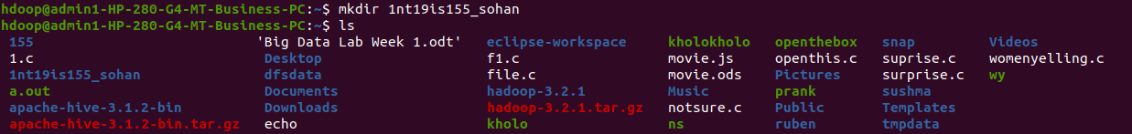

2. Add two empty files into it

hadoop fs -touchz /sohan/file1.txt

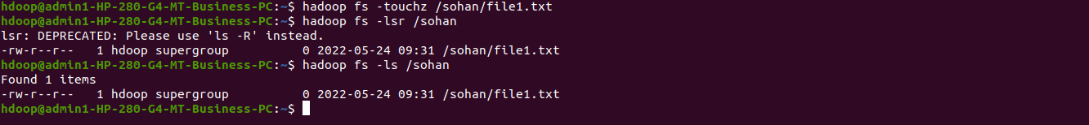

hadoop fs -touchz /sohan/file2.txt

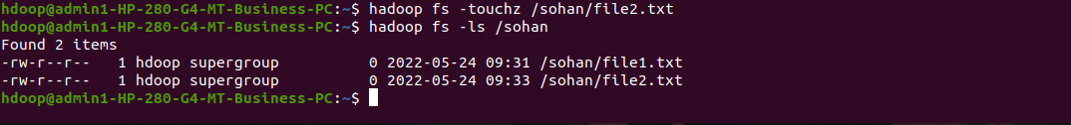

3. List all the files in the directory that you have created

hadoop fs -ls /sohan

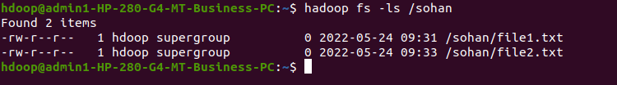

4 Create one more directory by your usn and put that inside the directory of your name

hadoop fs -mkdir /sohan/1nt19is155
hadoop fs -ls /sohan

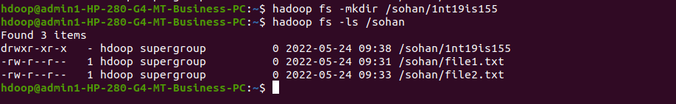

5. Create a file in your local system by the name_usn.txt and add the contents as
"Syntax to list Is command is hadoop fs -Is "

cat > sohan_1nt19is155.txt
cat sohan_1nt19is155.txt

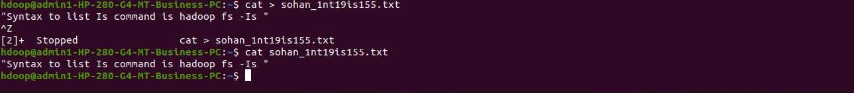

►Put the file usn_name.txt in your hdfs directory called usn
hadoop fs -copyToLocal /sohan/file1.txt
hadoop fs -copyToLocal /sohan/file2.txt

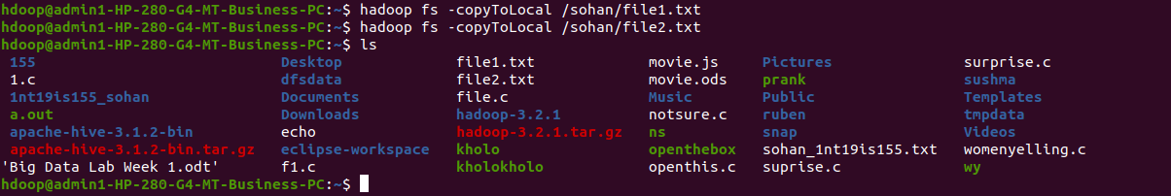

Put empty file of hdfs into the local file system

hadoop fs -moveFromLocal sohan_1nt19is155.txt/sohan/1nt19is155
hadoop fs -ls /sohan/1nt19is155

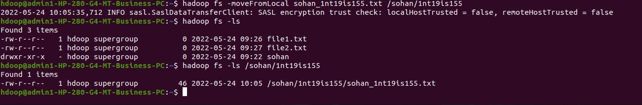

Experiment of cp command

hadoop fs -cp /sohan/file1.txt /sohan/1nt19is155
hadoop fs -ls /sohan/1nt19is155

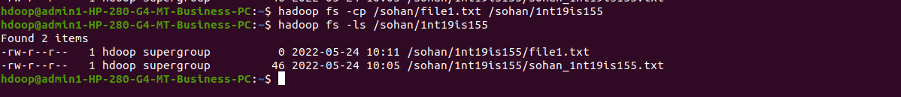

►Use mv command to move files from local file system and hdfs file system

hadoop fs -mv /sohan/file2.txt /sohan/1nt19is155

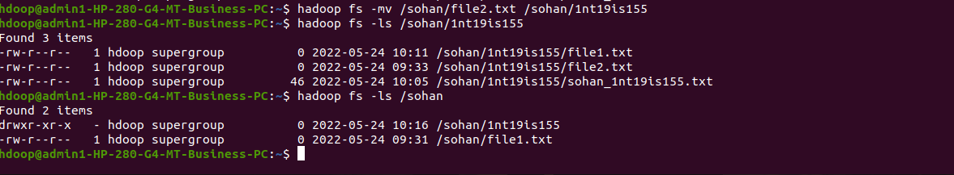

► Display the total size of all the files in name directory

hadoop fs -du /sohan/file2.txt /sohan/1nt19is155

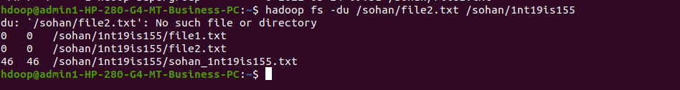

► Display each file size in usn directory Use stat command on name and usn directories

hadoop fs -stat /sohan

hadoop fs -stat sohan/1nt19is155

Illustrate the use of append command

cat > file1.txt

“JAI RCB”

hadoop fs -appendToFile file1.txt /sohan/1nt19is155/file2.txt

hadoop fs -cat /sohan/1nt19is155/file2.txt

